METADATA CONFIGWORKBOOK

# Pre-Requisites

1. Salesforce.com user id and password.
2. JDK 6.0

# Installation Instructions

1. Extract the attached zipfile in folder.

# 

1. ConfigWorkbook.zip contains three files :
2. ConfigWorkBook.jar (Executable ZAR to execute the program directly)
3. config.properties (This file contains information like username, password etc). Below attached is a sample config file and usage of all the properties.
4. package.xml (This file contains information regarding what metadata should be fetched).A sample package.xml has been attached.



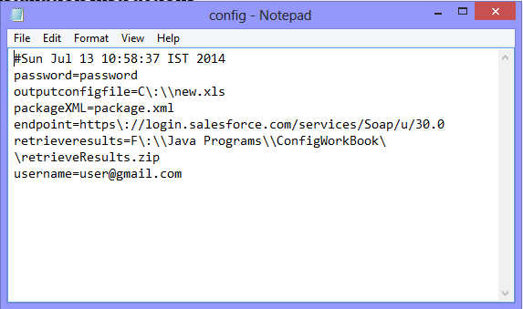

Please configure all the properties in the file according to your, failure to do so might cause some errors.

Details of ‘config.properties’

1. Password :- Enter your Salesforce password
2. Outputconfigfile:- Location where your excel sheet will be stored (Mandatory)
3. packageXML :- Location where your package.xml is stored (Mandatory)
4. endpoint:- Your endpoint url to Salesforce.

Production/Developer: *https\://login.salesforce.com/services/Soap/u/30.0*

Sandbox: https\://test.salesforce.com/services/Soap/u/30.0

1. retrieveresults: Path where your retrieved metadata would be saved(Mandatory)
2. username:- Your Salesforce username



**Execution: (through login page)**

1. Double click on the ‘ConfigWorkBook.jar’ for execution
2. This screen will appear

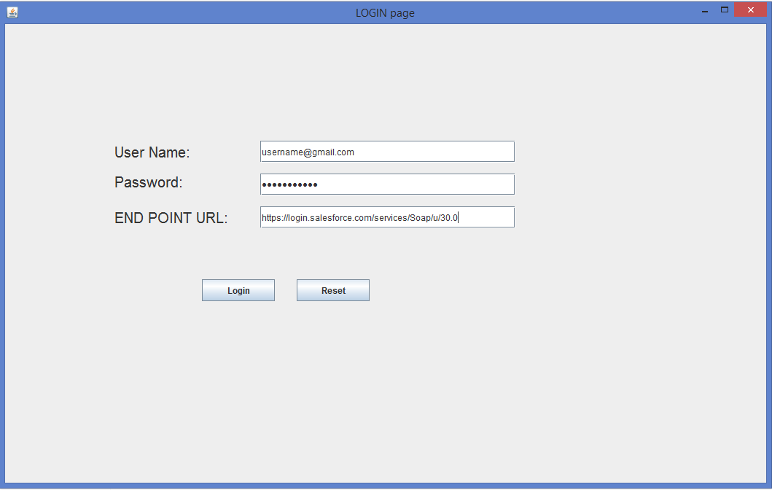

Submit all the details correctly and click on the ‘Login’ button

1. After clicking on the ‘Login’ button wait for the loading to complete

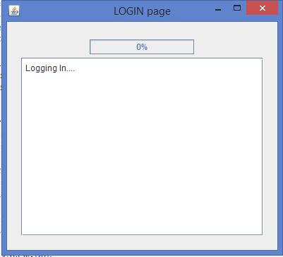 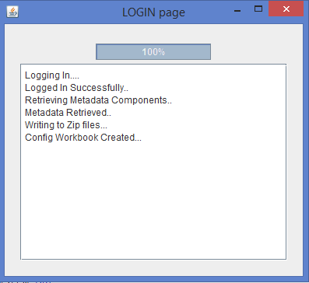

1. Go to the folder where your ConfigWorkBook excel sheet is created. (Path you gave in ‘outputconfigfile’)

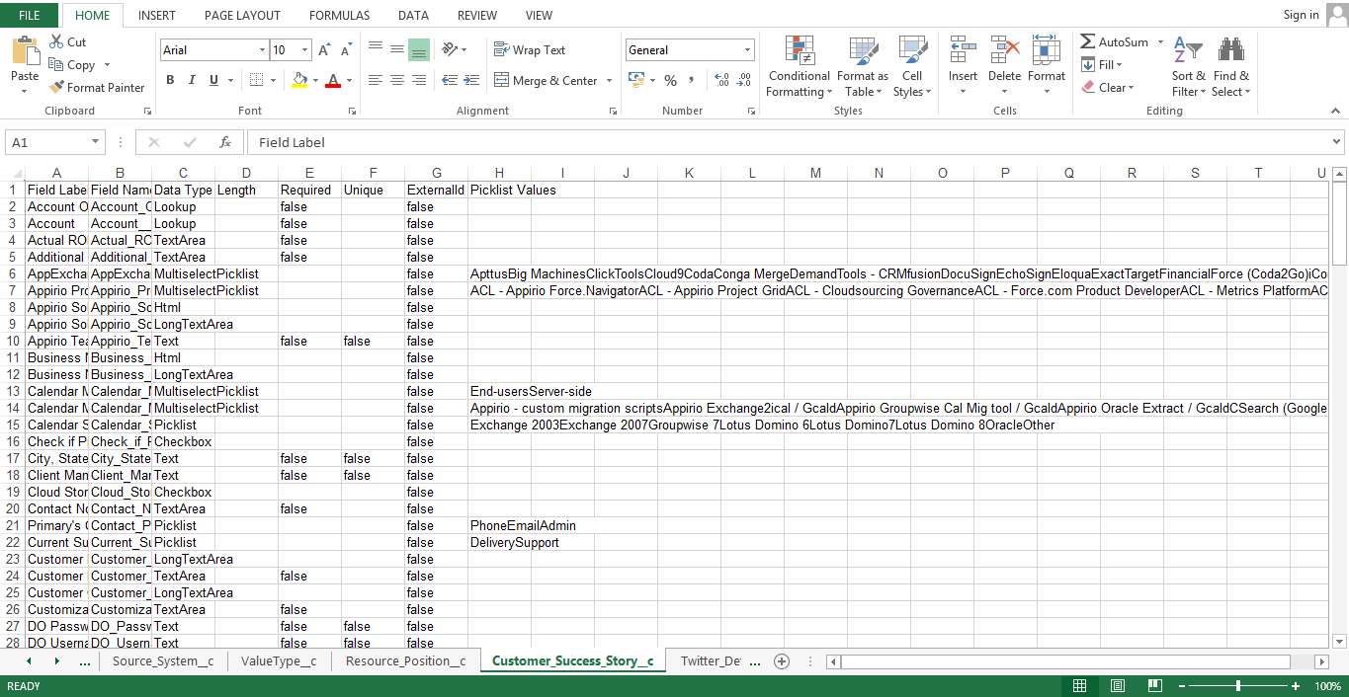

**Execution through Command Prompt:-**

1. Open the command prompt
2. Enter the following command

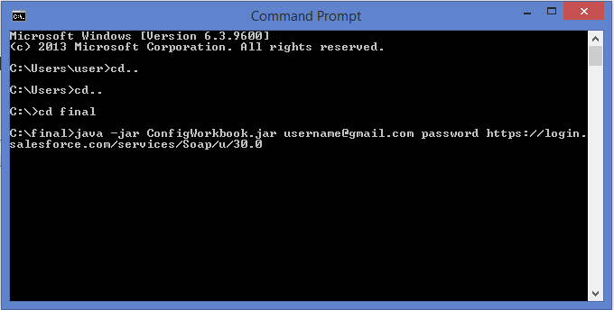

Click enter

1. Wait for the processing to complete

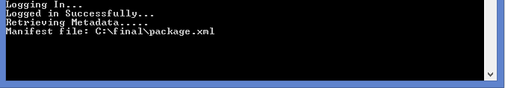

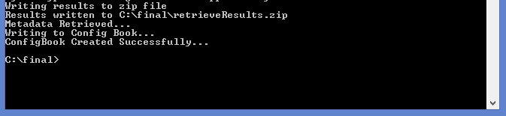

1. Go to the folder where your excel sheet is created to access it

**Now you can also login through command prompt with the help of config.properties file**

1.Enter the following code into your command prompt

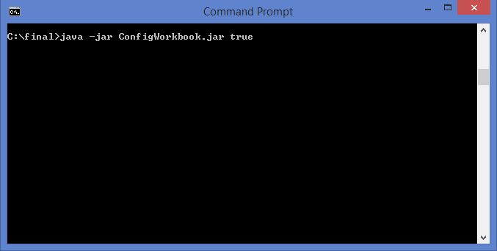





Watch this video for more clarifications :

http://screencast.com/t/OR6a2N6Xa5R